o Product description and features

This is an internship database that will be composed of different tables that will help a student navigate through the system and find any information about any specific internship. The system will require the student to register first before being able to utilize the database.

o Analysis and development techniques applied

The user can't modify the view. The view will go directly to the internship table.

Highlight assumptions and any elements that are simulations of production   
processes (i.e., you couldn’t implement or finish, but provided small simulation)

* The student will be able to insert personal information in the Internship database.
* Students will be able to apply for internships through the Create Application button.
* Companies can enter all the required information about their internships to be viewed by the students.

o Application architecture chosen and why  
 What might the application architecture look like in a production system

* We created the database on PyCharm to connect all the information about the database and create tables for the different entities of the internship database
* We implemented Tinker for the graphical user Interface (GUI) which is a python interface toolkit.
* ER-Model (or ERD) diagram with relationships and cardinalities (not in 2-4 pages above)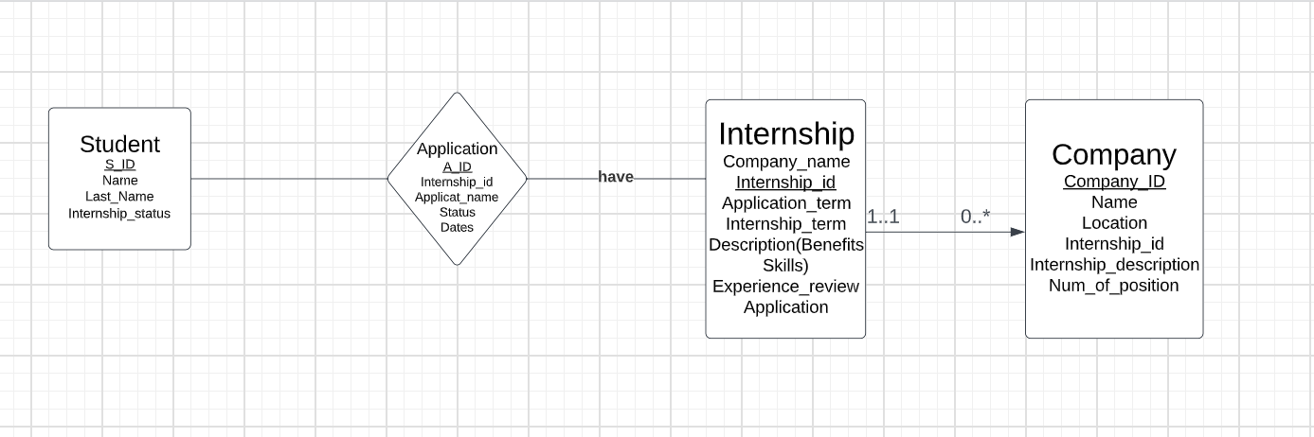
* Application Architecture Diagram (may be included in 2-4-page document if takes up less than 1/3 of a page)

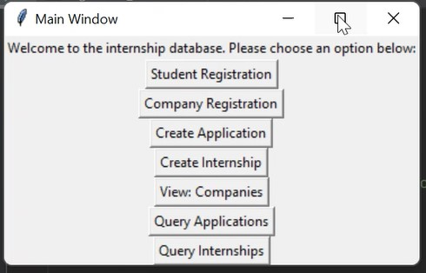

DDL scripts with table creation for all tables with primary/foreign keys, proper data types, and   
any necessary check constraints

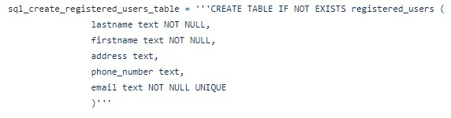

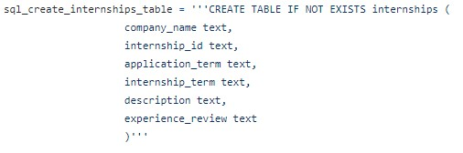

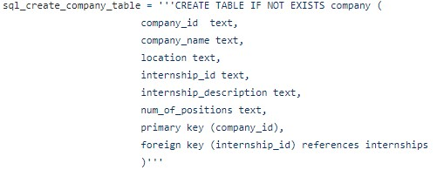

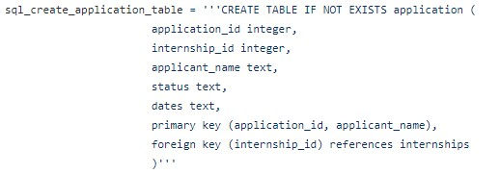

DML statements for CRUD operations on all tables

Inserting into the database

